Example:
When adding, the children count in ones from the start number until they have added the amount they need to. Then will repeat the same process with the next amount, rather than recording singular jumps.
6+7+4= 17
+4
+7
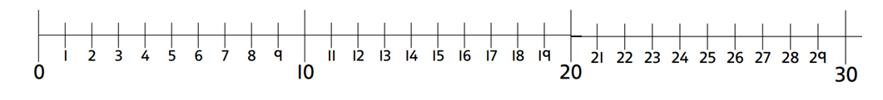

5+3+4=

6+5+8=

7+8+4=

8+9+4=

5+7+8=

7+8+8=

Can you make some of your own problems and answer them using a number line?
____+___+___=____

