Can you add some adjectives to this picture to describe the dragon?

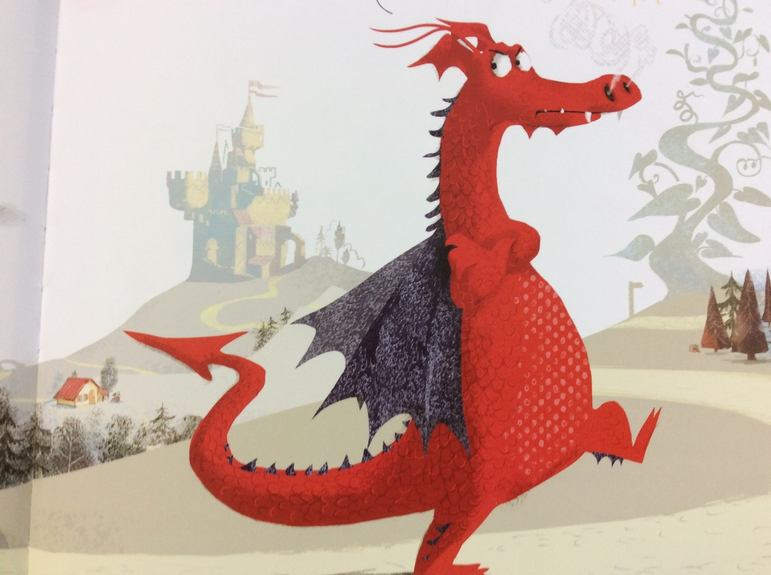

What adjectives could we use to describe dragon?
e.g.- colour, size, his character.
Remember to use your senses
What does he look like?
What does he feel like?
Does he smell of anything? (Smokey breath)
What does his voice sound like?

