How would you describe dragon?

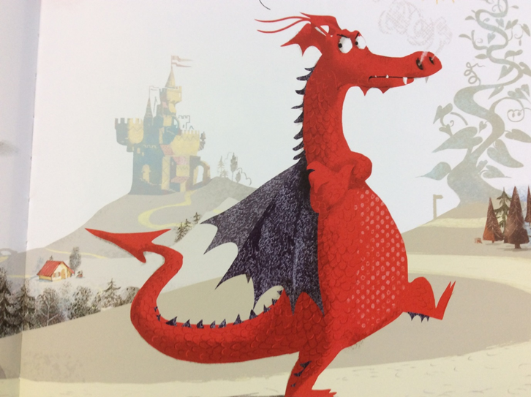
What adjectives could you use to describe dragon? (Use the word bank of adjectives to help if you need it).

________________________________________________________________________________________________________________________________________________________________________________

ADJECTIVES WORD BANK

red blue green bright
huge giant small tiny

sad confused heroic brave

scared frightened kind thoughtful

excited clever useful happy

sharp angry fiery hot

