Monday 8th January 2021 – Phonics
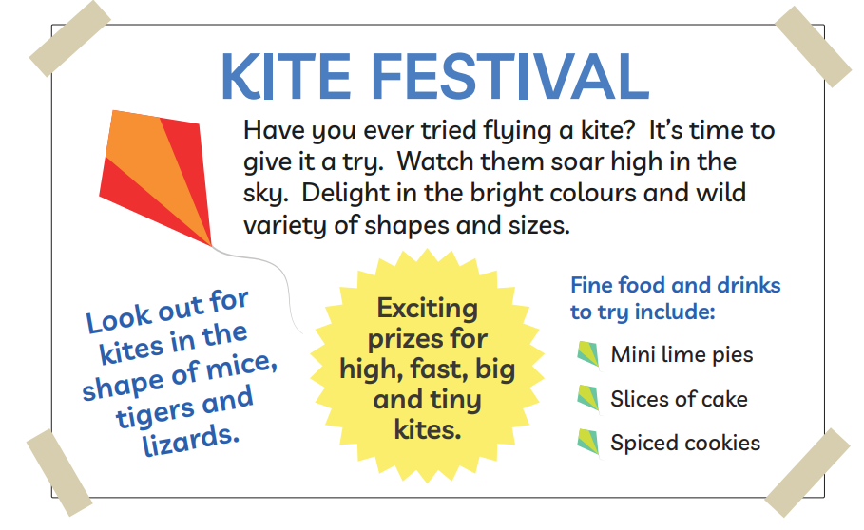
Today we are recapping alternative igh spellings. Can you underline all of the words with the igh sound in? How many did you find?

